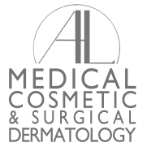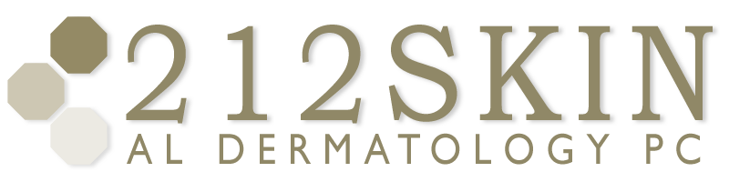
AL DERMATOLOGY PC
LYUBOV AVSHALUMOVA D.O. F.A.O.C.D.
80 BEEKMAN STREET NEW YORK, NY 10038

_____________________________________________________________________________________________
P: (212) 729-SKIN (7546) | F: (212) 729-9395 | Email: contact@212skin.com | www.212SKIN.com

Fax from: AL Dermatology, P.C. / 212SKIN.COM
Fax number: 212-729-9395
Phone number: 212-674-7777
Date:
___________________________________________________
Attention:
Fax to number:
Phone:
Pages sent: (including cover sheet)

THIS FACSIMILE MESSAGE IS INTENDED ONLY FOR THE SOLE CONFIDENTIAL USE OF THE INDIVIDUAL OR ENTITY TO WHICH IT IS ADDRESSED AND MAY CONTAIN INFORMATION THAT IS PRIVILEGED, CONFIDENTIAL AND EXEMPT FROM DISCLOSURE UNDEDR APPLICABLE LAW. IF YOU ARE NOT THE INTENTEED RECIPIENT YOU ARE HEREBY NOTIFIED THAT ANY USE, REVIEW, DISSEMINATION, DISTRIBUTION, DUPLICATION OR STORAGE Of THIS MESSAGE IS STRICTLY PROHIBITED. IF YOU HAVE RECEIVED THIS COMMUNICATION IN ERROR, PLEASE NOTIFY US IMMEDIATELLY BY TELEPHONE AND DESTROY OR RETURN THE ORIGINAL MESSEGE TO 212SKIN AL DERMATOLOGY, P.C., 80 BEEKMAN STREET, NEW YORK, NY 10038 VIA U.S. POSTAL SERVICE.

